Linear Algebra: Part 2
Note: Here in this part, we'll learn about Matrices and its different operations.
Moreover, in this part we'll only learn about Matrices and in next part, we'll have the intuition of what we learn today.

Suggestion
Bold blue = important words / key terms.
Purple bold = notations, symbols and section labels.
Green italic = references (algorithms, named rules, examples).
Red bold and the bordered boxes = formulae and matrices.
Everything else is the original explanation kept as written. Extra explanations, corrections and any unclear handwriting are only written under the Suggestion box at the end of each topic.

1) Types of Matrices.
Topics covered: 1) Types of matrices 2) Matrix equality 3) Scalar operations 4) Matrix addition, subtraction and multiplication 5) Transpose of a matrix 6) Determinant 7) Minor 8) Co-factor 9) Adjoint 10) Inverse of a matrix 11) Solving a system of linear equations.
1) Row matrix:
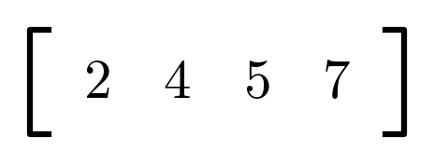

2) Column matrix.
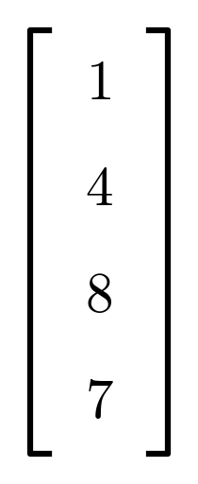

3) Square matrix: No. of rows = No. of columns.
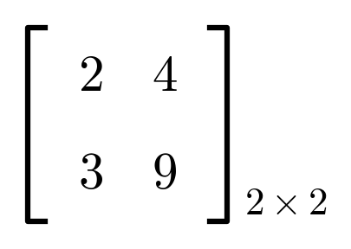
In square matrix, elements at Ann are called diagonals.
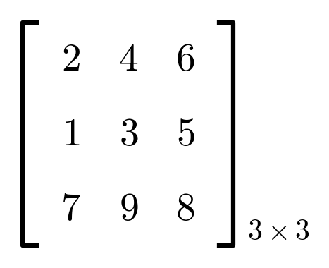

3) Diagonal matrix: A square matrix whose all non-diagonal elements are zero.

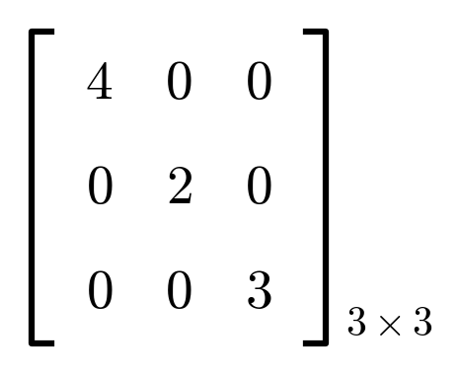

Suggestion
- The notebook numbers Square matrix and Diagonal matrix both as "3)", one right after the other. This looks like a small numbering slip; from "Scalar matrix" onward the numbering continues correctly as 4, 5, 6, 7.
- In the 3×3 square matrix example, the diagonal elements (top-left to bottom-right) are circled in the notebook: 2, 3 and 8.
- In the Diagonal matrix example, the exact top-left number is not fully clear in the handwriting; it has been read here as 4 (with the other diagonal entries 2 and 3, and all non-diagonal entries 0).

4) Scalar matrix: A square matrix whose diagonal element are equal, and other elements are zero.
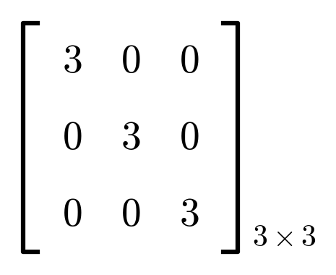

5) Identity matrix: A square matrix whose diagonal elements are 1 and other are zero.
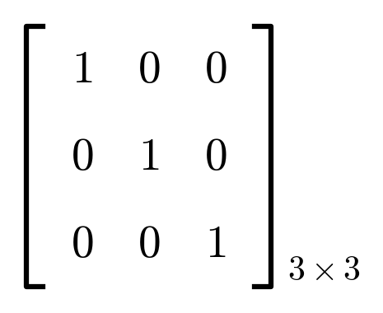

6) Zero matrix: A matrix where all elements are zero. This is a 2×3 zero matrix.
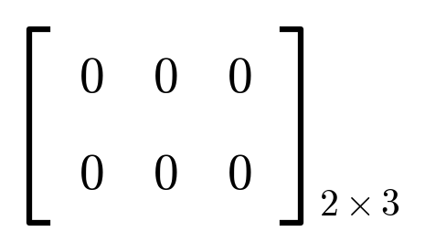

7) Ones matrix: A matrix whose all the elements are one. This is a 2×3 ones matrix.
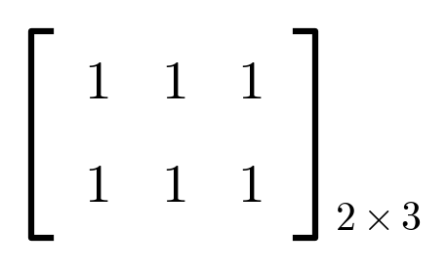

Suggestion
- A scalar matrix is just a diagonal matrix where every diagonal entry happens to be the same number (here 3, 3, 3).
- The identity matrix is a special scalar matrix where that repeated number is 1. It behaves like the number 1 does in ordinary multiplication (see Multiplicative Identity later in this document).
- A zero matrix and a ones matrix don't need to be square; the notebook's examples are both 2×3.

2) Matrix equality.
1) If shape of matrices are same and
2) All the elements of both the matrices are same.
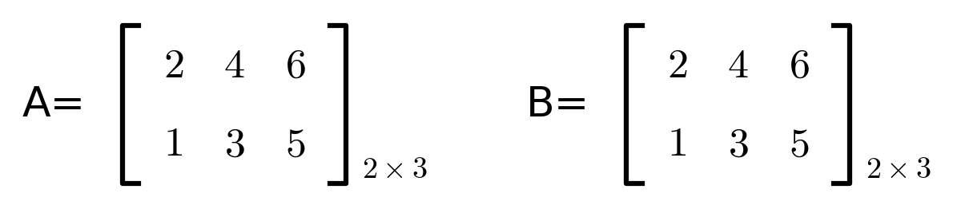
Here A = B.

Suggestion
- Both conditions must hold together: same shape and same elements in the same positions. If either fails, the two matrices are not equal, even if they contain the same numbers in a different arrangement.

3) Scalar operations:
There're two types of scalar operations.
i) Addition/subtraction
ii) Multiplication.
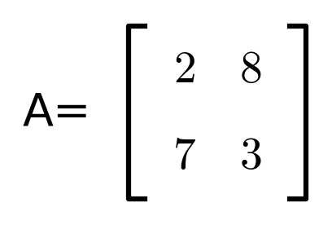

K = 2
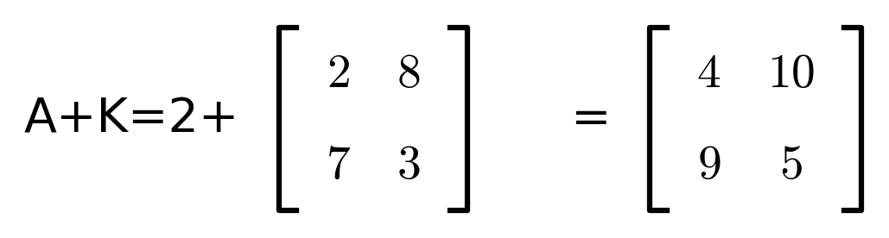
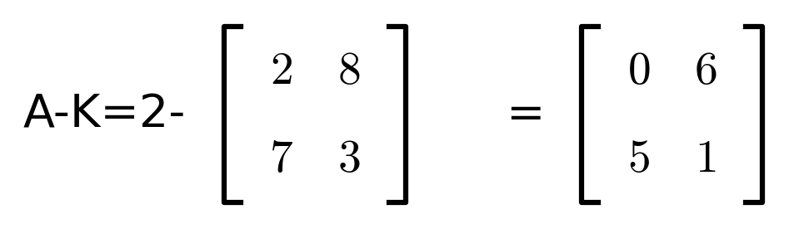
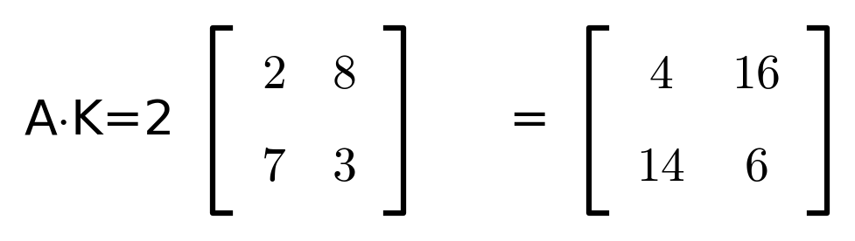
⇒ Multiplying a matrix with (−1) gives negative of that matrix.
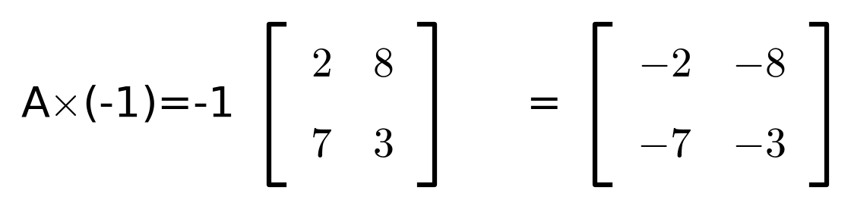
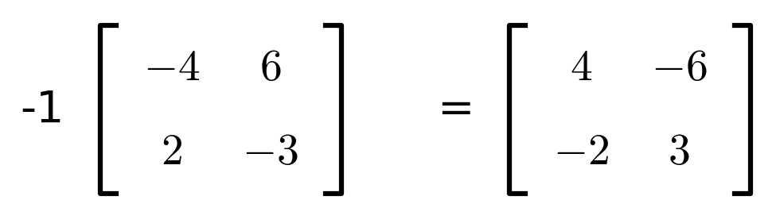
• If A, B and C are matrices,
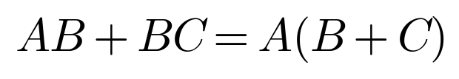

Suggestion
- In a scalar addition/subtraction, the same number is added to (or subtracted from) every element of the matrix.
- In a scalar multiplication, every element of the matrix is multiplied by that number.
- The rule AB + BC = A(B+C) at the bottom of this topic has a second version, (A+B)C, crossed out in the notebook; it was probably an incorrect first attempt that was corrected to A(B+C).

4) Matrix Addition, and subtraction. and Multiplication.
i) Matrix addition:
• Shape of all the matrices should be same.
• The resultant matrix will be of same shape.
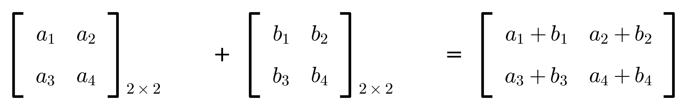
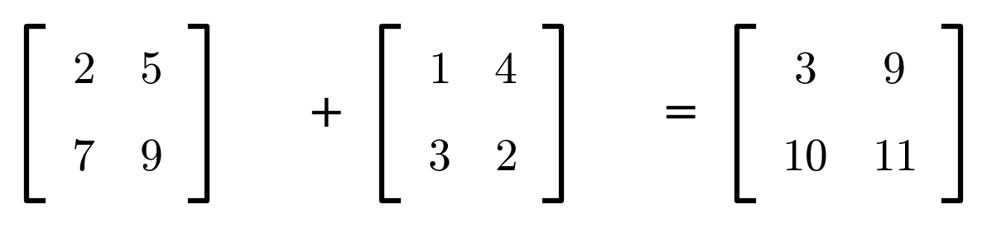
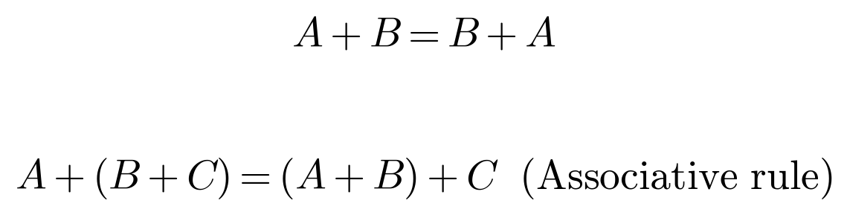

ii) Matrix subtraction:
• There is nothing like matrix subtraction.
• We basically combine scalar multi and matrix addition to perform matrix subtraction.
• We perform A + (−1)B

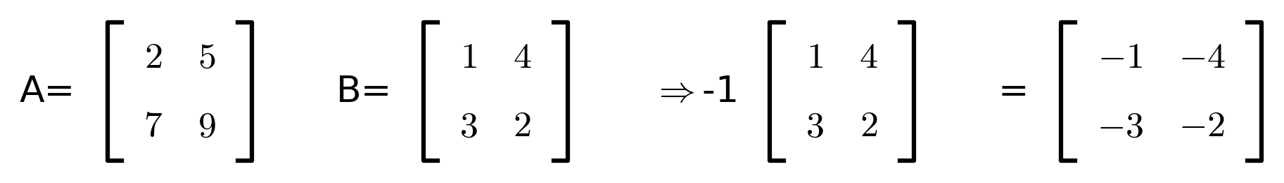
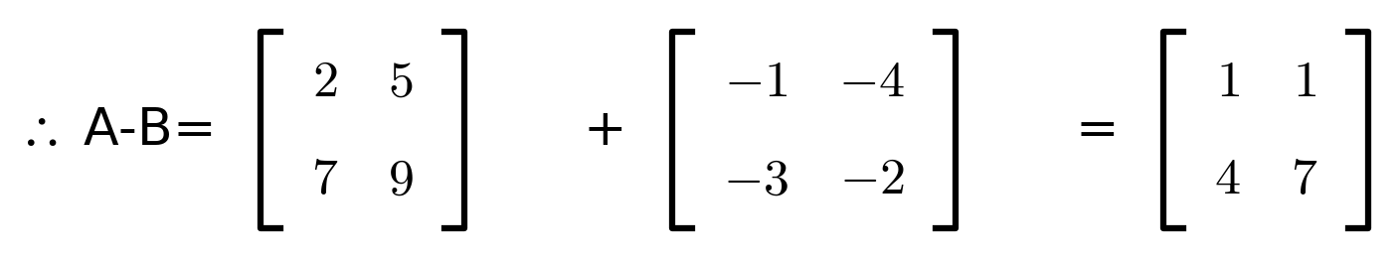
• This is how it is mathematically but we can simply do A − B
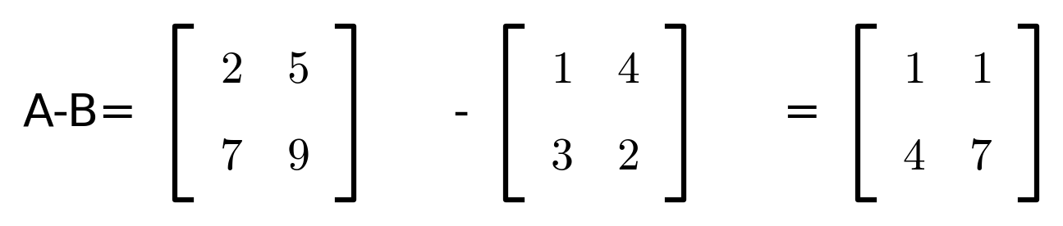

Suggestion
- The two ways of finding A − B give the same answer: formally, negate B first and add it to A; in practice, just subtract matching elements directly, as the last line shows.

A) Additive Identity
– A + X = A
– For example
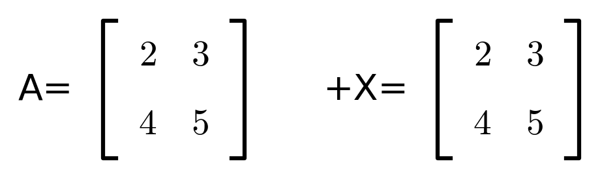
– We know that X should be of same shape then only addition can be performed.
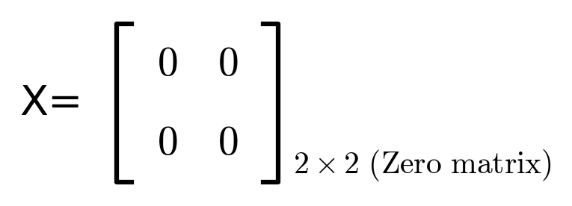
– So, for any matrix, an additive identity is always a zero matrix of same size.
B) Additive Inverse
– A + X = Zero matrix.
– For example
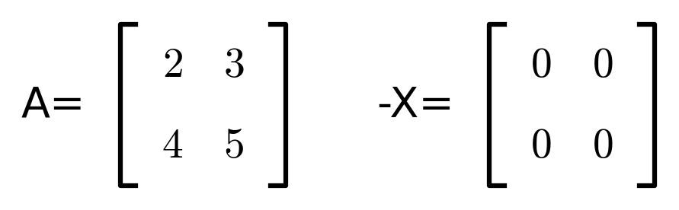
– Obviously X should be of same shape.
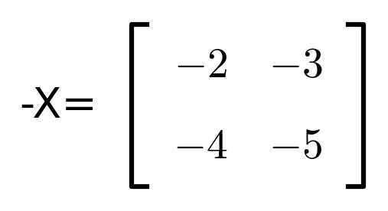

(−X) = −A
– So for any matrix, an additive inverse is always the negative matrix of that particular matrix.

5) Matrix Multiplication.
Rules:
i) Multiplication of Matrices is only possible if no. of columns of A = no. of rows of B. n = m
ii) The resultant matrix is always of size no. of rows of A × no. of columns of B. m × r

Suggestion
- The additive identity is always a zero matrix of the same shape; the additive inverse of any matrix is always that matrix multiplied by −1.
- The multiplication rule n = m means: the number of columns in the first matrix must equal the number of rows in the second matrix. If A is (rows × n) and B is (m × cols), multiplication A·B needs n = m, and the answer's shape is (rows of A) × (columns of B).

For example:
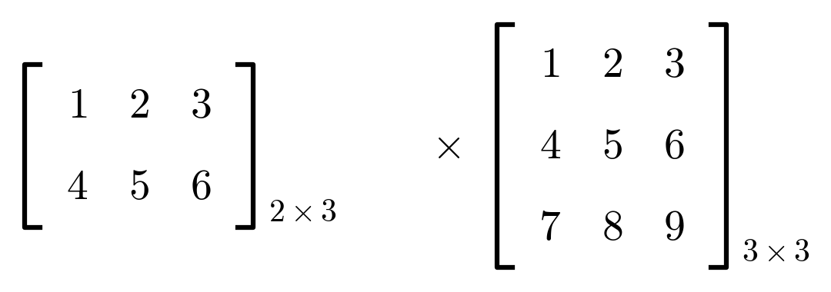
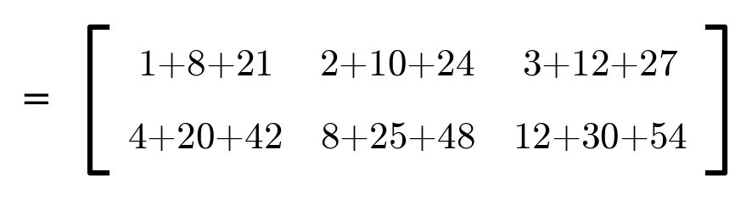
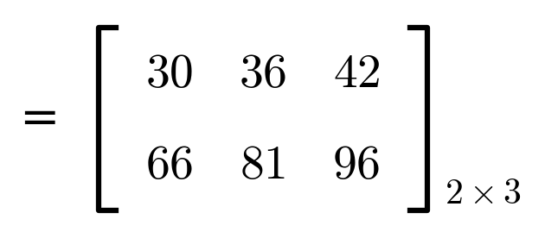
→ Some important points.
• AB ≠ BA
For example: A = (2,3) and B = (3,3)
A.B is possible but B.A ? B = (3,3), A = (2,3). So B.A is not possible. Hence AB ≠ BA.
• Associative rule is applicable. (AB)×C = A(BC)
• AB + AC = A(B+C)
⇒ Multiplicative Identity.
• A·X = A.
For example
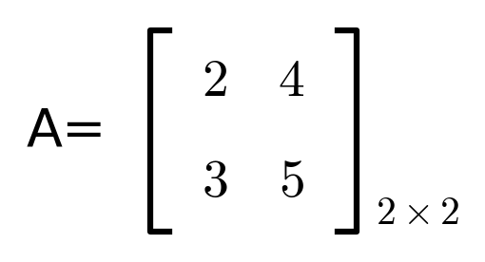
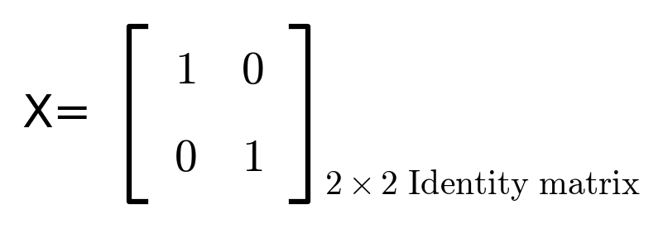
• So for any matrix, multiplicative identity is always an identity matrix. Hence,
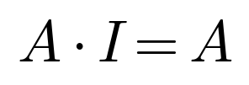

Suggestion
- Here A = (2,3) means a matrix with 2 rows and 3 columns, and B = (3,3) means 3 rows and 3 columns; these are shapes, not the matrices' actual number entries.
- A.B works because A's columns (3) match B's rows (3). B.A would need B's columns (3) to match A's rows (2), which fails — so order matters for matrix multiplication, unlike ordinary number multiplication.
- Multiplicative identity means: multiplying any square matrix by the identity matrix of the same size leaves it unchanged, the same way multiplying a number by 1 leaves it unchanged.

6) Transpose of a Matrix.
Row becomes column and column becomes row.
For example:
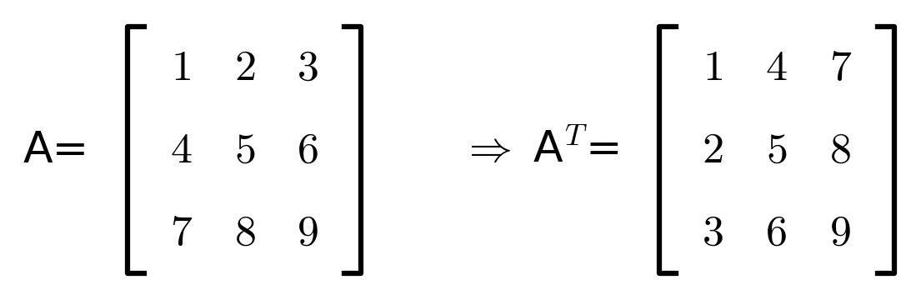

7) Determinant of a Matrix.
i) A = [4] (1×1). det(A) = 4
ii)
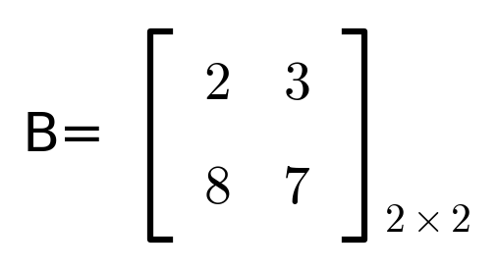
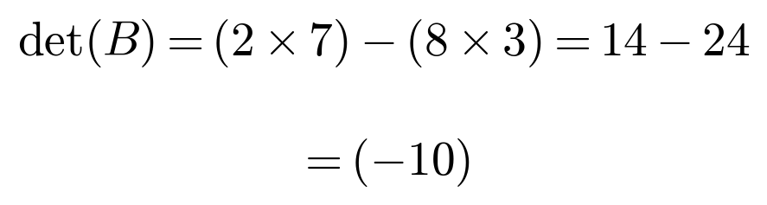

iii)
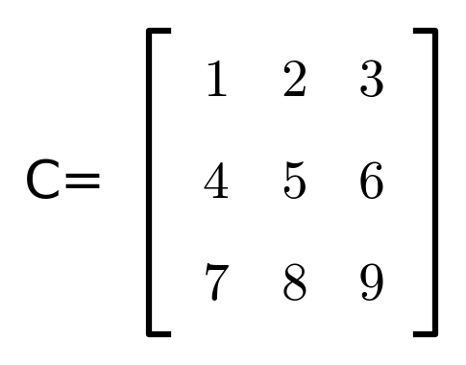
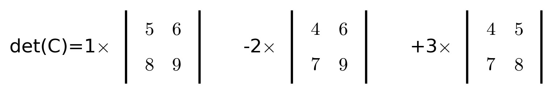
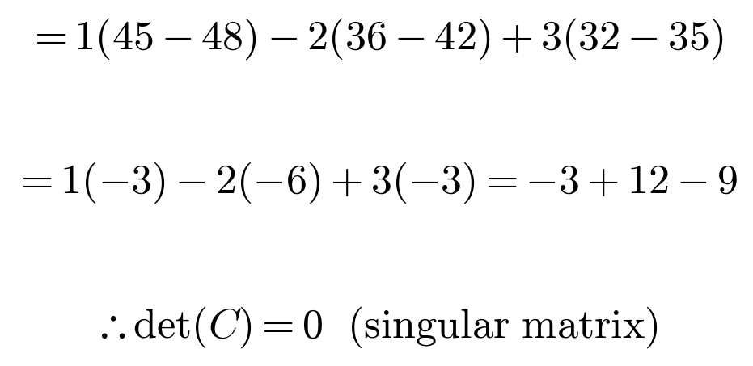
Note: A matrix whose determinant is zero is called a singular matrix.

Suggestion
- Transpose just swaps rows and columns; it works for matrices of any shape, not only square ones. Determinant, on the other hand, is defined only for square matrices.

8) Minor.
– Every element of a matrix will have its own minor.
– To find the minor of an element, delete its row and column and find the determinant of the other elements. This is the minor of that element.

– It is denoted by Mij.
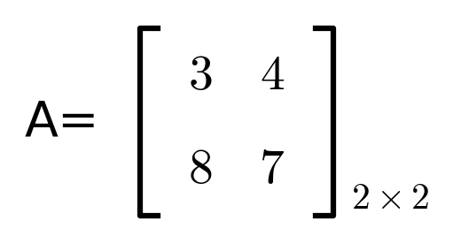
• Minor(3) = 7, Minor(4) = 8
• Minor(8) = 4 and Minor(7) = 3

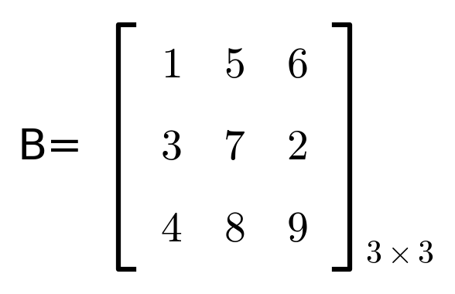
• Minor(1) = (7×9−8×2) = 47, Minor(5) = (3×9)−(4×2) = 19
• Minor(6) = (−4), Minor(3) = (−3), Minor(2) = (−12)
• Minor(4) = (−32), Minor(8) = (−16), Minor(9) = (−8)
– We define minor for a matrix and not a scalar. Even if we do try to find the minor of a scalar we delete row and column, so that single element gets deleted and remains an empty matrix. Determinant of an empty matrix is 1, so minor of a matrix (scalar) is 1.

Suggestion
- Each "Minor(x)" here names the minor by the value of the element it is centred on, not by its row/column position. So "Minor(1)" means the minor of the element whose value is 1, which sits at row 1, column 1 of B.

9) Cofactor.
– Cofactor is denoted by A.
Formula:
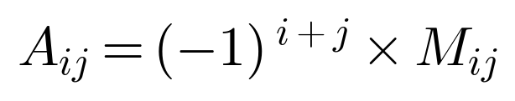
1 =
– A11 = (−1)1+1 × M11 ⇒ (7×9)−(8×2) = 47 ⇒ 1 × 47 = 47
5 =
– A12 = (−1)1+2 × M12 = 19 ⇒ (−1) × (19) = (−19)
6 =
– A13 = (−1)1+3 × M13 = (−4) ⇒ 1 × (−4) = (−4)
...lly, find co-factor of other elements.

Suggestion
- "...lly" is short for "Similarly": once you know the pattern (sign from (−1)i+j, multiplied by the minor), the remaining six cofactors of B are found the same way — their values are used directly in the next topic (Adjoint).

10) Adjoint of a matrix.
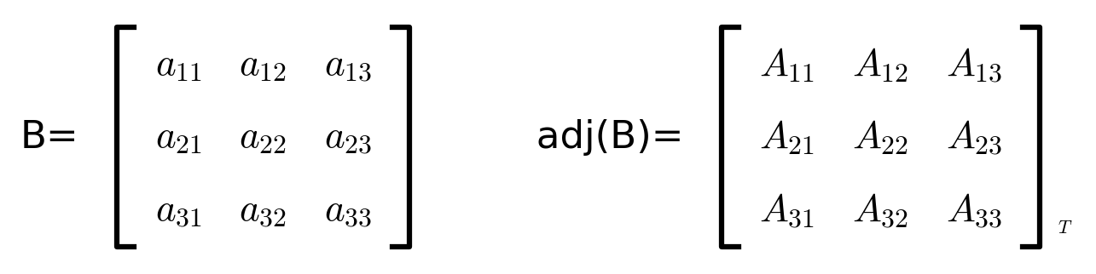
where A = Cofactor.
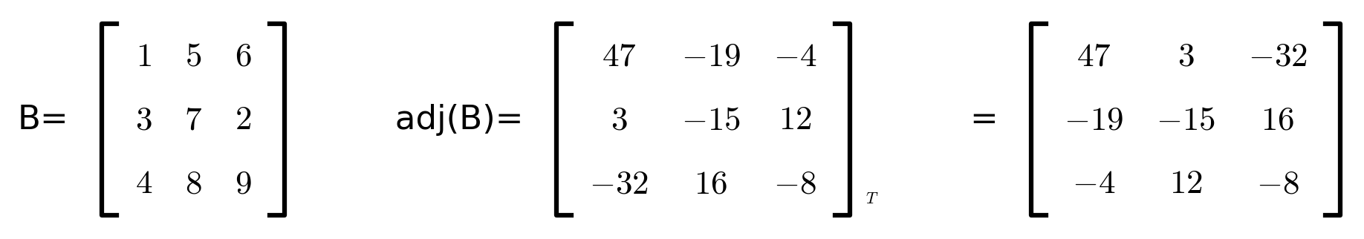
A11 = (−1)² × 47 = 47 A22 = (−1)⁴ × (−15) = (−15) A33 = (−1)⁶ × (−8) = (−8)
A12 = (−1)³ × 19 = (−19) A13 = (−1)⁴ × (−4) = (−4)
A31 = (−1)⁴ × (−32) = (−32) A21 = (−1)³ × (−3) = 3
A32 = (−1)⁵ × (−16) = 16 A23 = (−1)⁵ × (−12) = 12

Suggestion
- The adjoint is the matrix of cofactors, transposed (rows swapped with columns). Notice the final adj(B) has the cofactors' rows and columns swapped compared to the cofactor matrix listed just above it — that swap is exactly what the little T (transpose) means.

11) Inverse of a matrix.
– An inverse matrix is a matrix which when multiplied with the original matrix, results into an identity matrix.
– A . A−1 = I.
– The inverse matrix is defined only for square matrices.
– Not all square matrices have an inverse.
– A matrix is invertible only if it is non-singular, meaning its determinant is non-zero.
– If the determinant of A is zero, it is a singular matrix and it doesn't have an inverse.
– Applications of inverse matrix are solving system of linear equations, find the solution of matrix eqn and performing various matrix operations.
Formula:
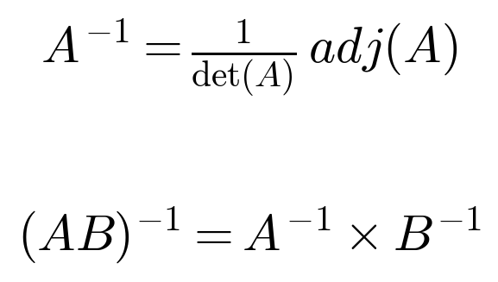

Suggestion
- Think of the inverse matrix like a reciprocal: just as multiplying a number by its reciprocal gives 1, multiplying a matrix by its inverse gives the identity matrix I. And just as 0 has no reciprocal, a singular matrix (det = 0) has no inverse.

12) Solving a system of linear equation.
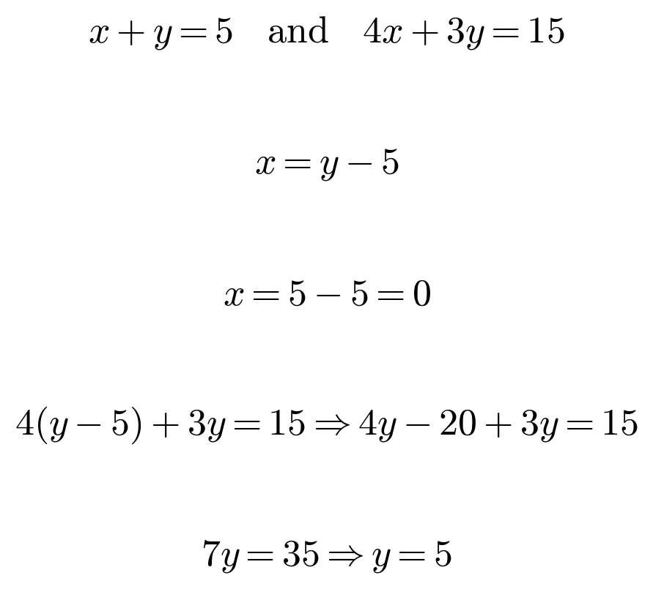
Now let's solve this using matrix's method.
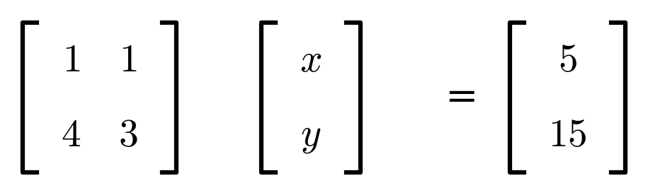
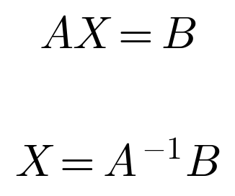
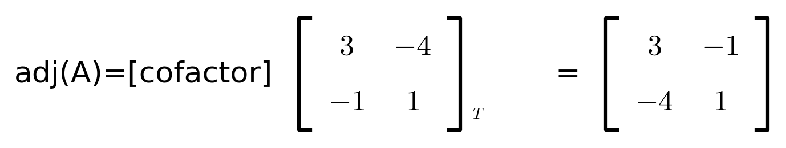
∴
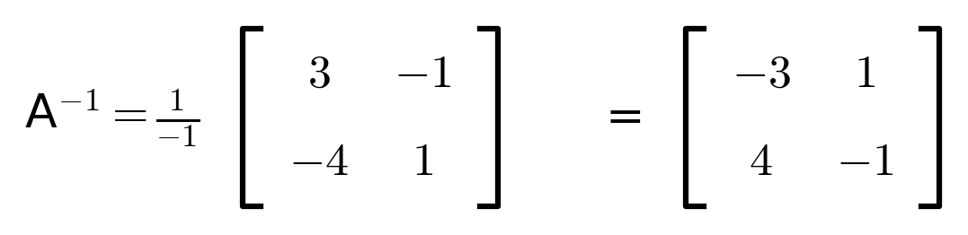
⇒
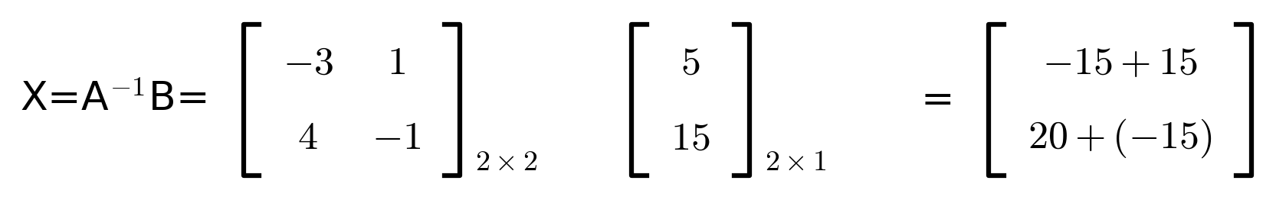
∴
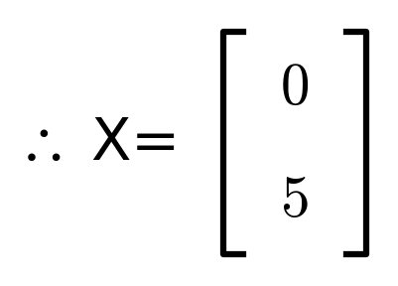

Suggestion
- Check: substitute x = 0, y = 5 back into the original equations. x + y = 0 + 5 = 5 ✓. 4x + 3y = 0 + 15 = 15 ✓. Both match, confirming the matrix method gives the same answer as the direct substitution method used at the top of this topic.
- This matrix method (using X = A−1B) works for any number of linear equations, not just two — that generality is exactly why it's useful, even though for just two equations, direct substitution is often quicker by hand.

